

申请會員類別/Types of Member ：
資深會員/ Senior Member
姓名/Name | 性別/Sex | 生日/Birthday
身份證號/ID. | 手機/Cel. | 座機/Tel.
Email | 聯絡地址/Add.
職業經歷/Professional History

個人榮譽/ Personal Honors

審核意見/ Discussion and Consideration Report

注：每位會員需提供2張彩色個人照片,與會員費付款成功憑證和申請表一併發到下方郵箱。
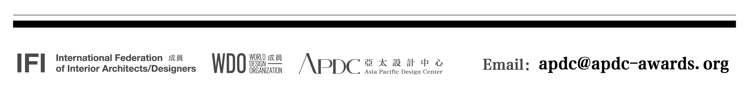
Note: Each member shall provide 2 personal color photos and submit them to the email below together with the successfully paid payment voucher of membership fee and the application form.

